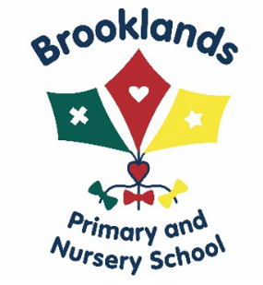
Our Early Help Offer
Many families experience periods where family life has complications. There are times when you need additional help and support. This can come in many different forms and these form our Early Help offer. If you have a concern please contact your child’s class teacher or Mrs Linda Hibbert, our Family Liaison Lead. Someone will contact you as soon as possible and arrange a meeting or have a discussion over the phone.

What can we offer?
We can offer someone to talk to, advice where appropriate we, can signpost parents to different agencies for further information and support.

What concerns might parents share?
There is a wide range of concerns that parents might have, these can include:
Behaviour Management
Financial difficulties
Housing
Benefits
Bereavement
Domestic Violence
Mental health
Medical Worries
School attendance

The list above is only a brief outline of the help that can be offered. Any problems can be discussed privately and confidently. If we are unsure of a specific support group we will contact other agencies to gain the correct advice.
What support will be on offer?
Sometimes just a chat and sharing ideas can be all it takes to start a positive reaction to a problem. However, with our team we have specific training and skills to share, these include:
Trained safeguarding leads
Mental health first aider
SENCO
ELSA
Nurture

How will the support be managed?
Initial meetings will be arranged and informal support and ideas will be offered. Plans and suggestions made will be recorded for future reference. Where necessary links may be made with local schools if the issues are affecting the whole family.
Sometimes, it may be necessary to complete an Early Help assessment and take advice from other
Agencies, this will be discussed and parental consent will be granted before this level of support is
used. There is specific form that will need to be completed at this stage which will be discussed and shared at all stages. At this level, more formal meetings will be arranged in order to put in specific targets in to support the family and individuals.

What happens if the help school offer is not enough?
Where improvements and suggested plans are not helping, school will contact a range of outside professionals for further advice and support. These include:
- School Nurse
- Speech and Language Therapists
- Behaviour Support
- Educational Psychologist
- Young Carers
- Family GP
- The Early Help Team
- CAMHS
- Counselling Services

