

SEND Information Report
2024-25

Our Aims and Ethos at
Brooklands Primary and Nursery School

At Brooklands our values are central to everything that we do. Together, the children and staff have identified our Brooklands Values which, as a school, we all agree to abide by.

As well as our school values we have great ambition for our school. We are committed to our school being at the heart of the school community. Local groups use our site and we regularly invite local businesses into school to promote aspirations and to give the children a wider sense of community.

We are proud of Brooklands and of our thriving school community. Our shared vision for our school compliments our values and ensures we are all focused on making Brooklands a place where everyone reaches their potential.

Meet the Brooklands SEND Team

Miss House is the SENDCO in school. She has responsibility for coordinating the provision for all children in the school who have Special Educational Needs or disabilities (SEND).

You can contact her by email:
sendco@brooklands.derbyshire.sch.uk

Miss House is supported by a highly trained and experienced team in the day-to-day support for children with SEND.


Miss McHale is the Assistant SENDCO in school. She works alongside Miss House to coordinate the provision for children in school who have SEND.


Mrs Hibbert is our Child and Family Support Worker and our trained ELSA (Emotional Literacy Support Assistant). She works closely with Miss House and Miss McHale, in providing support to families of Brooklands pupils. She works on a 1:1 and group basis with children who need additional support with their social and emotional needs.

Our aims

• To monitor the progress of all pupils.
• To identify the needs of pupils with SEND as early as possible.
• To make appropriate provision to overcome all barriers to learning and ensure pupils with SEND have full access to the National Curriculum.
• To work closely with children and parents.
• To work with and in support of outside agencies where necessary.
• To create a school environment where pupils feel safe to voice their opinions about their needs and the provision made to meet them.

How do we identify children with SEND?

It is likely that the majority of children will experience some level of difficulty at some point during their time in education, however some children and young people may require additional support to remove barriers to their learning. This is based on an understanding that all children and young people are entitled to an education that is responsive to their needs, promotes high standards and opportunities to explore their hopes and aspirations, regardless of their starting point, background or area of need.

At Brooklands, we use a Graduated Approach to identify children with SEND and put relevant support in place.

The following diagram shows the process that we follow:

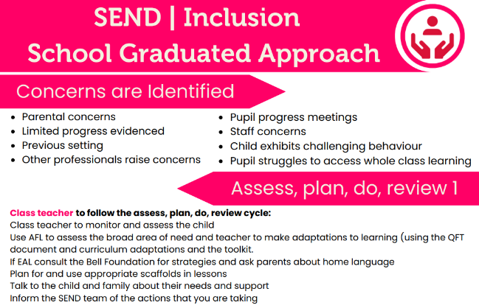
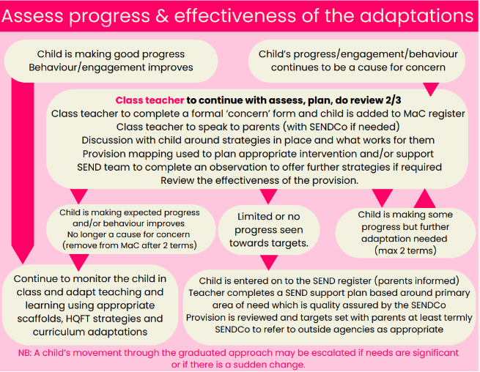

How do we work with parents and carers?

Brooklands believes that a close working relationship with parents is vital. No pupil will be entered onto the school’s SEND Register without prior discussion with parents.

The school endeavours to recognise and remove barriers for pupils with SEND through an ongoing discussion with parents to develop an evolving understanding of the pupil’s strengths and needs. This will be informed by the:
• early and accurate identification and assessment of SEND leading to appropriate interventions and provision
• detailed tracking to ensure the continued social and academic progress of children with SEND
• reviewing and setting of outcomes to ensure that these remain tailored to the individual needs of the pupil.

Parents are kept up to date with their child’s progress through termly reviews, parent consultation evenings and informally through conversations when dropping off or collecting their child at the end of the day. In cases where more frequent regular contact with parents is necessary, this will be arranged based on the individual pupil’s needs. The SEND Team may also signpost parents of pupils with SEND to the local parent support services where specific advice, guidance and support may be required.

If an assessment or referral indicates that a pupil has additional learning needs, the parents and the pupil (as appropriate) will always be consulted with regards to future provision. Parents will be consulted, and their consent sought, before the school seeks to involve external education support services.

What is our approach to teaching
children with SEND?

Pupils with SEND will be given access to the curriculum through the specialist SEND provision provided by the school as is necessary, as far as possible, in line with the wishes of their parents and the needs of the individual.

Every effort will be made to educate pupils with SEND alongside their peers in a mainstream classroom setting. Where this is not possible, the SEND Team will consult with the child’s parents for other flexible arrangements to be made.

To ensure all children are able to access the curriculum at an appropriate level and fulfil their potential we take some of the following actions:
• Keep staff fully informed of the special educational needs of any pupils in their charge including sharing progress reports, medical reports and teacher feedback.
• Provide regular training and learning opportunities for staff on the subject of SEND and

SEND teaching. School staff should be up to date with teaching methods which will aid the progress of all pupils including those with SEND and have documentation to support them with this.
• Make use of all class facilities and space.
• Use in-class provisions and support effectively to ensure that the curriculum is adapted where necessary.
• Make sure that individual or group tuition is available where it is felt that pupils would benefit from this provision.
• Set appropriate individual targets that motivate pupils to do their best and celebrating achievements at all levels.
• Any decision to provide group teaching outside the classroom will involve the class teacher and/or the SEND Team in providing a rationale and focus on flexible teaching. Parents will be made aware of any circumstances in which changes have been made.

Links with other agencies
and voluntary organisations

Brooklands invites and seeks advice and support from external agencies in the identification and assessment of, and provision for, SEND. The SENDCO is the designated person responsible for liaising with the following:
• Education Psychology Service (EPS)
• Children’s Social Care
• Speech and Language Therapy Service (SALT)
• Child and Adolescent Mental Health Services (CAMHS)
• Derbyshire Inclusion and Support Services

How do we know that the support
in place is working?

In order to make consistent continuous progress in relation to SEND provision the school encourages feedback from staff, parents and pupils throughout the year.

Pupil progress of children with SEND will be monitored on a termly basis in line with the SEND Code of Practice. Provision is recorded on individual SEND Support Plans and class teachers produce Class Provision Maps which provide a whole school provision map detailing the support that is in place. Interventions will be revisited regularly to ensure progress is being made. Pupils are consulted when their SEND Support Plan is written and when it is reviewed termly. Staff are asked for feedback in relation to their knowledge and skills and this leads into any training and/or support that they may require across the year.

How do we support children moving
between phases?

Children at Brooklands are supported with transition both on entry to our school and when they leave us for their next setting. We recognise that transition can be challenging for children with additional needs and therefore provide additional support in the following ways:
- Inviting parents in for transition meetings
- Visiting the child in their current setting
- Discussions between the SENDCOs of both schools / settings
- Additional visits to any new setting
- Supporting the child through transition books and social stories to help understand the process.
- Sharing of information, both verbally and by sharing the copies of SEND data kept in school.

What if I am not happy with the
support being provided?

If a parent or carer has any concerns regarding the provision, care or welfare of their child, in the first instance, an appointment should be made to speak to their child’s class teacher. Following on from this, an appointment can be made to speak to a member of the SEND Team who will be able to support further.

If further support is required after this stage, then please refer to the ‘Complaints Policy’ which can be found on our school website:
https://www.brooklands.derbyshire.sch.uk/policies/

The school’s SEND governor, Louise Williams, can also be contacted in relation to SEND matters.

Who can I contact for support?

Derbyshire has developed a SEND Local Offer, which is a resource that is designed to support children and young people with special educational needs and/or disabilities and their families. It describes the services and provision that are available both to those families in Derbyshire that have an Education, Health and Care Plan and those who do not have a plan, but still experience some form of special educational need.

The SEND Local Offer includes information about public services across education, health and social care, as well as those provided by the private, voluntary and community sectors.

https://www.localoffer.derbyshire.gov.uk/home.aspx

