

SEND and Inclusion Policy

Adopted: December 2024 Review date: December 2025

SEND and Inclusion at Brooklands Primary and Nursery School

At Brooklands our values are central to everything that we do. Together, the children and staff have identified our Brooklands Values which, as a school, we all agree to abide by.

As well as our school values we have great ambition for our school. We are committed to our school being at the heart of the school community. Local groups use our site and we regularly invite local businesses into school to promote aspirations and to give the children a wider sense of community.

We are proud of Brooklands and of our thriving school community. Our shared vision for our school compliments our values and ensures we are all focused on making Brooklands a place where everyone reaches their potential.

It is likely that the majority of children will experience some level of difficulty at some point during their time in education, however some children and young people may require additional support to remove barriers to their learning. This is based on an understanding that all children and young people are entitled to an education that is responsive to their needs, promotes high standards and opportunities to explore their hopes and aspirations, regardless of their starting point, background or area of need.

This should enable them to:

- achieve their best
- become confident individuals living fulfilling lives, and
- make a successful transition into adulthood, whether into employment, further or higher education or training

The framework for supporting children and young people with special education needs is contained within the SEN Code of Practice. A copy of which can be found on the Department for Education’s website:

www.education.gov.uk/schools/pupilsupport/sen

Derbyshire has developed a SEND Local Offer, which is a resource that is designed to support children and young people with special educational needs and/or disabilities and their families. It describes the services and provision that are available both to those families in Derbyshire that have an Education, Health and Care Plan and those who do not have a plan, but still experience some form of special educational need. The SEND Local Offer includes information about public services across education, health and social care, as well as those provided by the private, voluntary and community sectors.

https://www.localoffer.derbyshire.gov.uk/home.aspx

Our aims are:
- To monitor the progress of all pupils.
- To identify the needs of pupils with SEND as early as possible.
- To make appropriate provision to overcome all barriers to learning and ensure pupils with SEND have full access to the National Curriculum.
- To work closely with children and parents.
- To work with and in support of outside agencies where necessary.
- To create a school environment where pupils feel safe to voice their opinions about their needs and the provision made to meet them.

Responsibility for the coordination of SEN provision
- The person responsible for overseeing the provision for children with SEND is Mr Tom Daniel (Headteacher).
- The person co-ordinating the day to day provision of education for pupils with SEND is Miss Sarah House (SENDCO).

Arrangements for coordinating SEN provision
The SENDCO will hold details of all children that are on the SEND register, SEND Support Plans, a whole school provision map and individualised timetables.

All staff can access:

- The Brooklands Primary and Nursery School SEND Policy;
- The Brooklands Primary and Nursery School SEND Information Report;
- The Brooklands SEND Support Register;
- SEND Children’s Records (paper file and on SEND section of Microsoft Teams) which contain information on individual pupils’ special educational needs and/or disabilities, assessments, relevant reports from outside agencies, care plans and PEEPs;
- Guidance on the identification of a child with SEND through the Flying High Partnership’s ‘School SEND / Inclusion School Graduated Approach’ document;
- Information about types of special educational needs and disabilities with practical advice and teaching strategies through the Flying High Partnership’s ‘Supporting children with SEND through Quality First Teaching’ document and the ‘Curriculum Adaptations’ document;
- Information available through Derbyshire’s SEND Local Offer
(https://www.localoffer.derbyshire.gov.uk/home.aspx)

This information is made accessible to all staff in order to aid the effective co-ordination of the school’s SEN provision. In this way, every staff member will have complete and up-to-date information about all pupils with special needs and their requirements which will enable them to provide for the individual needs of all pupils.

Admission Arrangements
The admission arrangements for all pupils are in accordance with national legislation, including the Equality Act 2010. This includes children with any level of SEND; those with Education, Health and Care Plans and those without. Additional details of this are included within the admissions policy which can be found on the school’s website along with the policy.
https://www.brooklands.derbyshire.sch.uk/admissions/

Children at Brooklands are supported with transition both on entry to our school and when they leave us for their next setting. We recognise that transition can be challenging for children with additional needs and therefore provide additional support in the following ways:
- Inviting parents in for transition meetings
- Visiting the child in their current setting
- Discussions between the SENDCOs of both schools / settings
- Additional visits to any new setting
- Supporting the child through transition books and social stories to help understand the process.
- Sharing of information, both verbally and by sharing the copies of SEND data kept in school.

Facilities for pupils with SEND
The Brooklands Primary School site was opened in 2006 and is fully compliant with all disability requirements. We have ramped access to all doors, disabled toilet facilities, designated parking bays, and hearing loops in classrooms.

The school works very closely with the Local Authority access teams and will do all it can to support any child or staff member with a disability.

Allocation of resources for pupils with SEND
All pupils with SEND will have access to Element 1 and 2 of a school’s budget which equates to £6,000. Where it is felt a child meets criteria for any additional funding, a bid will be compiled by the SENDCO, with the support of the class teacher. Parents will also be contacted for their view on what is important for the child. This funding is accessed through the Derbyshire Inclusion Panel. The school will refer individual applications to the panel, which is administered by the Local Authority, who will determine whether the level and complexity of need meets the threshold for the additional funding. If the funding is agreed, it will then be allocated to additional provision to support the outcomes for the child that cannot be met within the schools own funding. This may involve: additional small group support or interventions, targeted adult support within class, support for non-structured times such as break and lunch times, access to inclusive technology to support their learning, the purchase of additional resources and/or supporting individual medical needs.

Identification of pupils needs

It is likely that the majority of children will experience some level of difficulty at some point during their time in education. However, some children and young people may require some additional support to remove barriers to their learning.

This is based on an understanding that all children and young people are entitled to an education that is responsive to their needs, promotes high standards and opportunities to explore their hopes and aspirations, regardless of their starting point, background or area of need.

This should enable them to:

• achieve their best

• become confident individuals living fulfilling lives, and

• make a successful transition into adulthood, whether into employment, further or higher education or training
The formal definitions of special educational needs (SEN) are taken from section 20 of the Children and Families Act 2014.

A child or young person has SEN if they have a learning difficulty or disability which calls for special educational provision to be made for them. A child of compulsory school age or a young person has a learning difficulty or disability if they:

- have a significantly greater difficulty in learning than the majority of others of the same age; or

- have a disability which prevents or hinders them from making use of educational facilities of a kind generally provided for others of the same age in mainstream schools or mainstream post-16 institutions.

A child under compulsory school age has special educational needs if they fall within the definition at (a) or (b) above or would do so if special educational provision was not made for them.
Although children must not be regarded as having a learning difficulty solely because the language or form of language of their home is different from the language in which they will be taught, due consideration should be given when assessing needs.

The School Graduated Approach
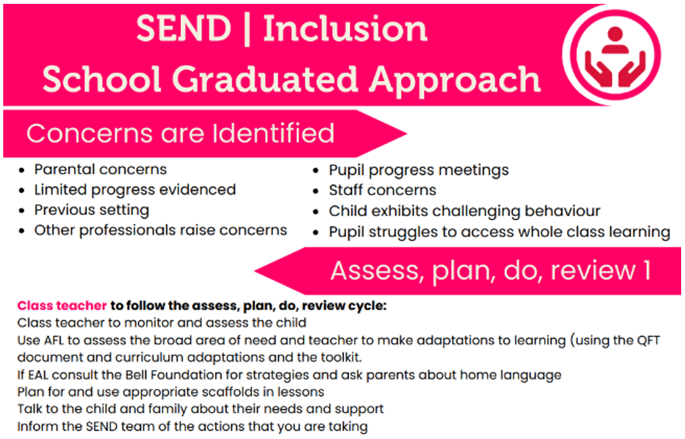
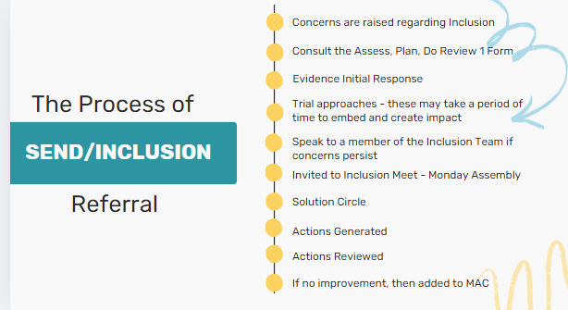

Assess, Plan, Do Review Form 1

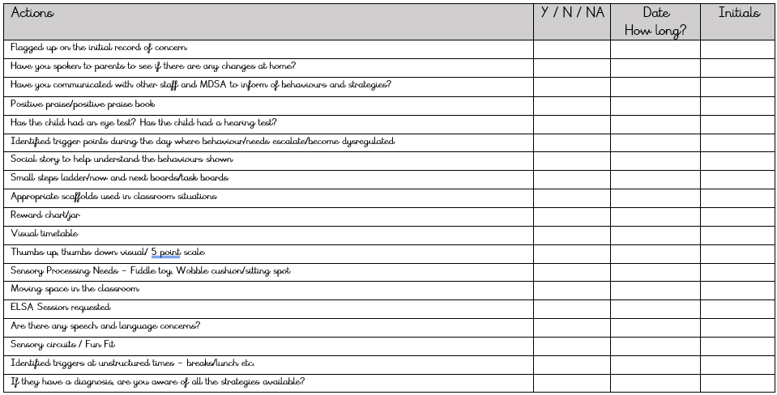

Assess, Plan, Do, Review – Stage 1

- Any pupils who have concerns identified will be monitored and assessed by the class teacher.
- The class teacher will use Assessment for Learning (AFL) to assess the broad area of need and will make adaptations to learning using the Assess, Plan, Do, Review 1 form, Quality First Teaching (QFT) document, the Curriculum Adaptations document and the Behaviour Toolkit.
- If the child has English an Additional Language (EAL), then the class teacher will consult ‘The Bell Foundation’ for strategies and ask parents about the child’s home language.
- The class teacher will plan for and use appropriate scaffolds in lessons.
- The class teacher will talk to the child and their family about their needs and support.
- The Inclusion Team can then be consulted by the class teacher for further support and advice if needed, wherein strategies are discussed and implemented.
- Following this, if concerns persist, the child will progress to Assess, Plan, Do Review – Stage 2.

*NB: A child’s movement through the graduated approach may be escalated if needs are significant or if there is a sudden change.
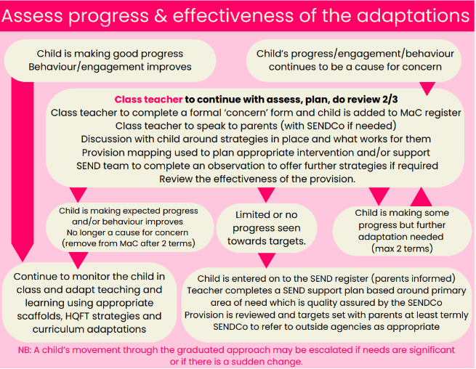
Assess, Plan, Do Review – Stage 2

Assess progress & effectiveness of the adaptations
- After 6-12 weeks*, if the child is making good progress and their behaviour/engagement improves, then the class teacher will continue to monitor the child in class and adapt teaching and learning using appropriate scaffolds, high QFT strategies and curriculum adaptations.]
- If the child’s progress/engagement/behaviour continues to be a cause for concern, the class teacher will continue with assess, plan, do review for a second period of time - approximately 6-12 weeks*.
- The class teacher will now complete an Initial Record of Concern Form (IRoC) and will email the SENDCO (sendco@brooklands.derbyshire.sch.uk) to register a formal concern so that the child can be added to the Monitoring and Concern (MaC) register.
- The class teacher will then speak to parents and the child (with the SENDCO/Assistant SENDCO if needed) about the strategies in place and what works for them.
- The SENDCO/Assistant SENDCO will plan appropriate intervention and/or support with the class teacher and this will be added to the class provision map by the class teacher.
- If required, the SENDCO/Assistant SENDCO will complete an observation to offer further strategies if required.
- After 6-12 weeks*, the effectiveness of the provision will be reviewed.
Reviewing the effectiveness of provision
- If the child is making expected progress and/or their behaviour improves, then they are no longer a cause for concern. The class teacher will continue to monitor the child in class and adapt teaching and learning using appropriate scaffolds, high QFT strategies and curriculum adaptations. The SENDCO will remove the child from the MaC Register after two terms.
- If the child is making some progress, but further adaptation is needed, then the class teacher will continue with the assess, plan, do, review cycle for an extended period of time (a maximum of two terms depending on the need of the child)*.
- If the child is making limited or there is no progress seen towards the targets, the class teacher will email the SENDCO to express their concern and they will discuss the child. If the SENDCO agrees, then the child will be entered on to the SEND register by the SENDCO and the class teacher will inform their parents. The class teacher will then complete a SEND Support Plan based around the child’s primary area of need which is quality assured by the SENDCO.
- The provision for the child will be reviewed and targets will be set with the child and their parents at least termly by the class teacher.
- The SENDCO/Assistant SENDCO will refer the child to outside agencies as appropriate.
*NB: A child’s movement through the graduated approach may be escalated if needs are significant or if there is a sudden change.

Request for an assessment - Education, Health and Care (EHC) Plan
If a child has lifelong or significant difficulties, it may be appropriate to consider a Statutory Assessment, which is usually requested by the school, but can be requested by a parent or young person, or in some instances by professionals from health and social care. This should begin with a conversation with the SENDCO.

Further information about EHC Plans can found via the SEND Local Offer:
https://www.localoffer.derbyshire.gov.uk/apply-for-an-assessment/ehc-plan/ehc-plan.aspx
Or by contacting the Derbyshire Information Advice and Support Service for SEND (DIASS) online at:
https://www.derbyshireiass.co.uk/parents-and-carers/information-for-parents-and-carers.aspx
Or by telephone on:
01629 533668
The application for an Education, Health and Care Plan will combine information from a variety of sources including:
- Parents
- Pupil
- Teachers
- SENDCO
- Educational Support Services
- Social Care
- Health professionals
Information will be gathered to inform a decision about whether an EHC Plan may be required. The request will be considered by a multi-agency panel. Parents have the right to mediation and ultimately can appeal against a decision not to initiate a Statutory Assessment leading to an EHC Plan.

Education, Health and Care Plans [EHC Plan]
- Following Statutory Assessment, an EHC Plan will be provided by Derbyshire County Council, if it is decided that the child’s needs are not being met by the support that is ordinarily available. The school and the child’s parents will be involved developing and producing the plan.
- Parents have the right to appeal against the content of the EHC Plan. They may also appeal against the school named in the Plan if it differs from their preferred choice.
- Once the EHC Plan has been completed and agreed, it will be kept as part of the pupil’s formal record and reviewed at least annually by the SENDCO, other school staff, parents/carers and the pupil. The annual review enables provision for the pupil to be evaluated and, where appropriate, for changes to be put in place, for example, reducing or increasing levels of support.

Access to the curriculum, information and associated services
Pupils with SEND will be given access to the curriculum through the specialist SEND provision provided by the school as is necessary, as far as possible, in line with the wishes of their parents and the needs of the individual.

Every effort will be made to educate pupils with SEND alongside their peers in a mainstream classroom setting. Where this is not possible, the SENDCO will consult with the child’s parents/carers for other flexible arrangements to be made.

To ensure all children are able to access the curriculum at an appropriate level and fulfil their potential we may take some of the following actions:
- Keep staff fully informed of the special educational needs of any pupils in their charge including sharing progress reports, medical reports and teacher feedback.
- Provide regular training and learning opportunities for staff on the subject of SEND and SEND teaching. School staff should be up to date with teaching methods which will aid the progress of all pupils including those with SEND and have documentation to support them with this.
- Make use of all class facilities and space.
- Use in-class provisions and support effectively to ensure that the curriculum is adapted where necessary.
- Make sure that individual or group tuition is available where it is felt that pupils would benefit from this provision.
- Set appropriate individual targets that motivate pupils to do their best and celebrating achievements at all levels.
- Any decision to provide group teaching outside the classroom will involve the class teacher and/or SENDCO/Assistant SENDCO in providing a rationale and focus on flexible teaching. Parents will be made aware of any circumstances in which changes have been made.

Inclusion of pupils with SEN
The inclusion of all pupils with SEND should be seen in the context of inclusion in its broadest sense, which will include the groups identified under the Equality Act 2010, namely those facing additional barriers due to race, gender, sexual orientation and religion. It is recognised that some pupils with SEND will also face additional barriers by virtue of the prejudices associated with belonging to these groups (whether conscious or unconscious).

The school curriculum is regularly reviewed to ensure that it promotes the inclusion of all pupils. This includes learning outside the classroom.

The school will seek advice, as appropriate, around individual pupils, from external support services as appropriate.

Evaluating the success of provision

In order to make consistent continuous progress in relation to SEND provision the school encourages feedback from staff, parents and pupils throughout the year.

Pupil progress of children with SEND will be monitored on a termly basis in line with the SEND Code of Practice. Provision is recorded on individual SEND Support Plans and there is a whole school provision map in place. Interventions will be revisited regularly to ensure progress is being made. Pupils are consulted when their SEND Support Plan is written and when it is reviewed termly. Staff are asked for feedback in relation to their knowledge and skills and this leads into any training and/or support that they may require across the year.

The SENDCO reports to the SEND Governor and/or Governors as requested to share the key headlines for SEND. There is also an annual update of the school SEND provision which is published on the school website (in accordance with section 69 of the Children and Families Act 2014). This is commonly known as the ‘SEND Information Report’. A link to the ‘SEND Information Report’ can be found on our school website:
https://www.brooklands.derbyshire.sch.uk/.

In service training (CPD)

We aim to keep all school staff up to date with relevant training and developments in teaching practice. The school will maintain a strategic overview of training for its staff which will include training opportunities targeted at specific areas of SEND and inclusion, more widely.

There are regular staff meetings that are dedicated to SEND. The focus is decided by gathering the views of staff, the specific needs of children in school and/or is linked to whole school needs and initiatives.

Alongside these, the SENDCO will inform staff on any training that may be available to them. This could include, but may not be limited to, a ‘drop in’ session, a face-to-face or online workshop for using different assessment tools and/or interventions that staff might like a refresher on. The SENDCO attends relevant SEND courses, Flying High Inclusion networks and Derbyshire LA SENDCO Training, then disseminates key messages from these learning opportunities.

The school continues to build strong working relationships and links with external support services in order to fully support our SEND pupils and facilitate school inclusion. We believe that sharing knowledge and information with our support services is key to the effective and successful SEND provision within our school.

Working in partnerships with parents
Brooklands believes that a close working relationship with parents is vital. No pupil will be entered onto the school’s SEND Register without prior discussion with parents.

The school endeavours to recognise and remove barriers for pupils with SEND through an ongoing discussion with parents to develop an evolving understanding of the pupil’s strengths and needs. This will be informed by the:
- early and accurate identification and assessment of SEND leading to appropriate interventions and provision
- detailed tracking to ensure the continued social and academic progress of children with SEND
- reviewing and setting of outcomes to ensure that these remain tailored to the individual needs of the pupil.

Parents are kept up to date with their child’s progress through termly reviews, parent consultation evenings and informally through conversations when dropping off or collecting their child at the end of the day. In cases where more frequent regular contact with parents is necessary, this will be arranged based on the individual pupil’s needs. The SENDCO may also signpost parents of pupils with SEND to the local parent support services where specific advice, guidance and support may be required.

If an assessment or referral indicates that a pupil has additional learning needs, the parents and the pupil (as appropriate) will always be consulted with regards to future provision. Parents will be consulted, and their consent sought, before the school seeks to involve external education support services.

If a parent or carer has any concerns regarding the provision, care or welfare of their child, in the first instance, an appointment should be made to speak to the class teacher. Following on from this, an appointment can be made to speak to the SENDCO/Assistant SENDCO who will be able to support further.

If further support is required after this stage, then please refer to the ‘Complaints Policy’ which can be found on our school website:
https://www.brooklands.derbyshire.sch.uk/policies/

The school’s SEND governor, Louise Williams, can also be contacted in relation to SEND matters.

Links with other schools
The school is a part of The Flying High Partnership, A MAT made up of more than 30 schools across Nottingham City, Nottinghamshire and Derbyshire. Within the partnership, there are opportunities of school to school support and learning as well as support through the Central Inclusion Team.

Links with other agencies and voluntary organisations
Brooklands invites and seeks advice and support from external agencies in the identification and assessment of, and provision for, SEND. The SENDCO is the designated person responsible for liaising with the following:
- Education Psychology Service (EPS)
- Schools and Families Specialist Services (SFSS)
- Children’s Social Care
- Speech and Language Therapy Service (SALT)
- Social Emotional and Mental Health Team (SEMH)
- Child and Adolescent Mental Health Services (CAMHS)
- Derbyshire Inclusion Support and Advisory Service (ISAS)

Representatives from voluntary organisations and other external agencies may be invited to liaison meetings throughout the year to discuss SEND provision and progress and keep staff up to date with legislation.

Parents/carers will normally be invited to and/or informed about meetings held concerning their child, unless there are over-riding safeguarding issues.

Signed: ______________________________ Mr Tom Daniel (Headteacher)

Date:

Signed: ______________________________ Miss Sarah House (SENDCO)

Date:

Signed: ______________________________ Miss Sophie McHale (Assistant SENDCO)

Date:

Signed: ______________________________ Mr Jake Bingham (Inclusion Team)

Date:

Signed: ______________________________ Mrs Linda Hibbert (Inclusion Team)

Date:

Signed: ______________________________ Louise Williams (SEND Governor)

Date:

This policy will be reviewed annually.

